Student Enrollment&Course Management System (SECMS)

User Story
The Student Enrollment&Course Management System (SECMS) is a Salesforce-based application developed to simplify and manage the academic activities of an educational institution. The system provides a centralized platform for handling student information, course details, enrollments, instructor assignments, approvals, payments, and academic reports.
Administrators and Enrollment Officers can use the system to maintain student records, manage course registrations, process enrollment requests, and monitor student-related activities. Instructors can access their assigned courses and manage academic tasks efficiently.
The system brings different academic processes together in one Salesforce environment, reducing manual work, improving data accuracy, and making information easier to access and manage.

1. INTRODUCTION

1.1 Project Overview
The Student Enrollment&Course Management System (SECMS) is designed to provide a centralized and organized platform for managing student enrollment and course-related activities. The application stores student, course, instructor, and enrollment information in a single Salesforce environment.
The system helps Enrollment Officers handle student admissions, course registrations, and communication. Administrators can monitor enrollment activities, manage course offerings, assign instructors, and review important academic information. The system also provides better visibility into the status of student enrollments and course allocations.
By using Salesforce features such as Flows, Approval Processes, Validation Rules, Reports, and Dashboards, the system can automate several routine activities. This helps reduce manual errors and ensures that enrollment processes are performed in a structured manner.
The application also supports monitoring of important information such as student enrollment status, course availability, enrollment volume, revenue details, and pending approvals. Overall, the project aims to make student and course management more efficient, transparent, and organized.

Main Objectives
- To maintain student information in a centralized system.
- To manage available courses and course registrations.
- To automate the student enrollment process.
- To assign instructors to appropriate courses.
- To reduce manual data entry and errors.
- To provide approval mechanisms for enrollment requests.
- To generate reports and dashboards for administrators.
- To improve communication between students, instructors, and administrators.
- To provide accurate and easily accessible academic information.

1.2 Purpose:
The main objective of SECMS is to replace manual and disconnected enrollment activities with a reliable, automated, and secure Salesforce solution that provides:
- Proper management of student information
- Well-organized enrollment processes
- Automated verification and approval procedures
- Clear reporting and continuous monitoring

2. IDEATION PHASE

2.1 Problem Statement (Customer Problem Statement Template)
PS | I am (Customer) | I’m trying to | But | Because | Which makes me feel
PS-1 | Enrollment Officer | handle student registrations effectively | enrollment information is spread across different sources | existing methods depend heavily on manual work | stressed and more likely to make mistakes
PS-2 | Administrator | monitor enrollments and related revenue | information is not available immediately | records are maintained separately | unsure when making important decisions
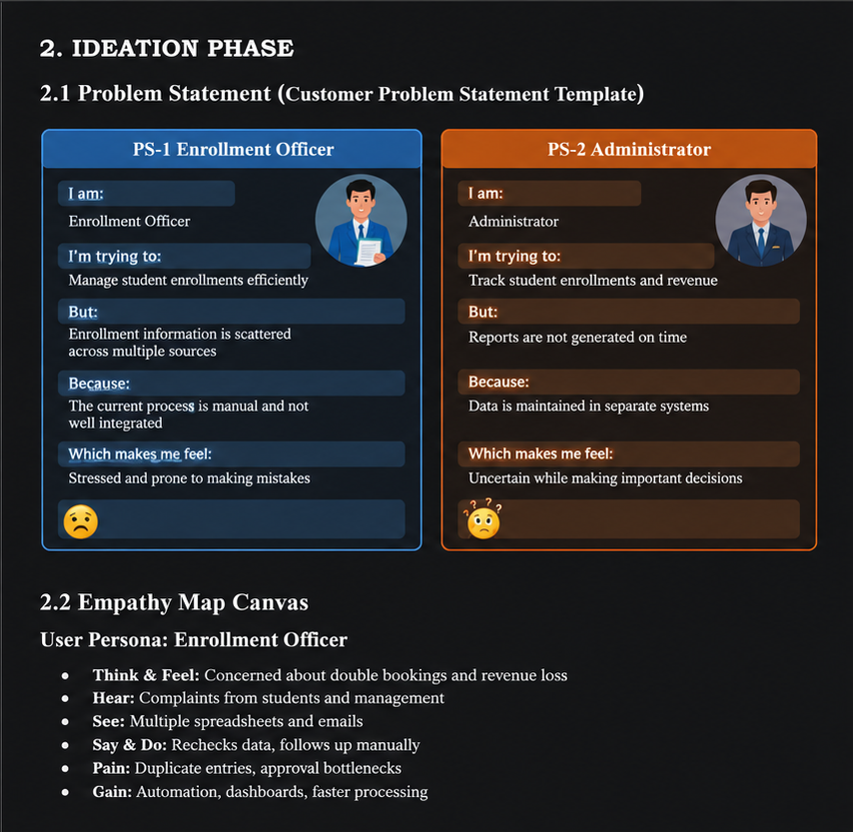

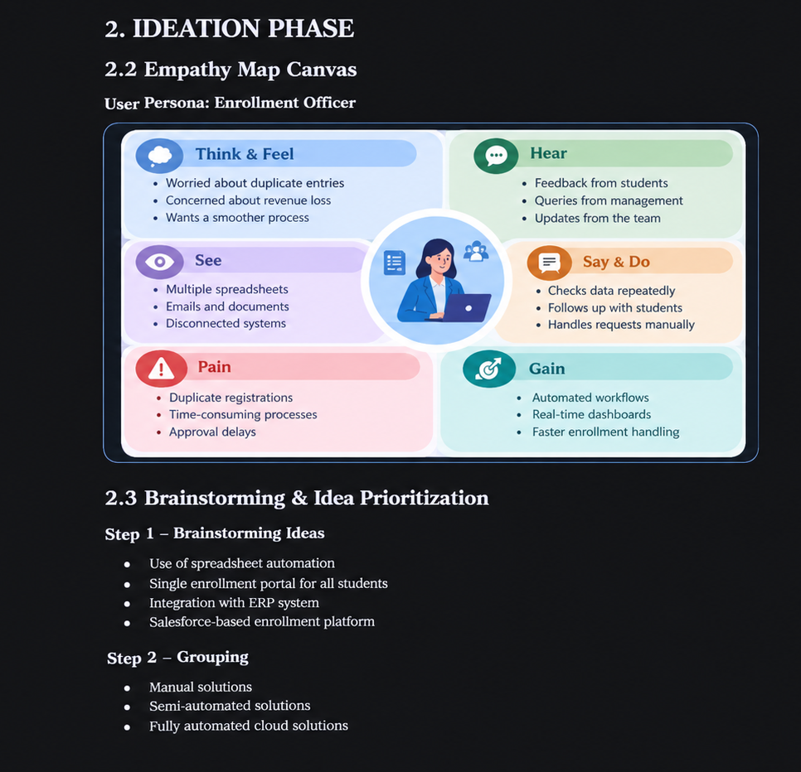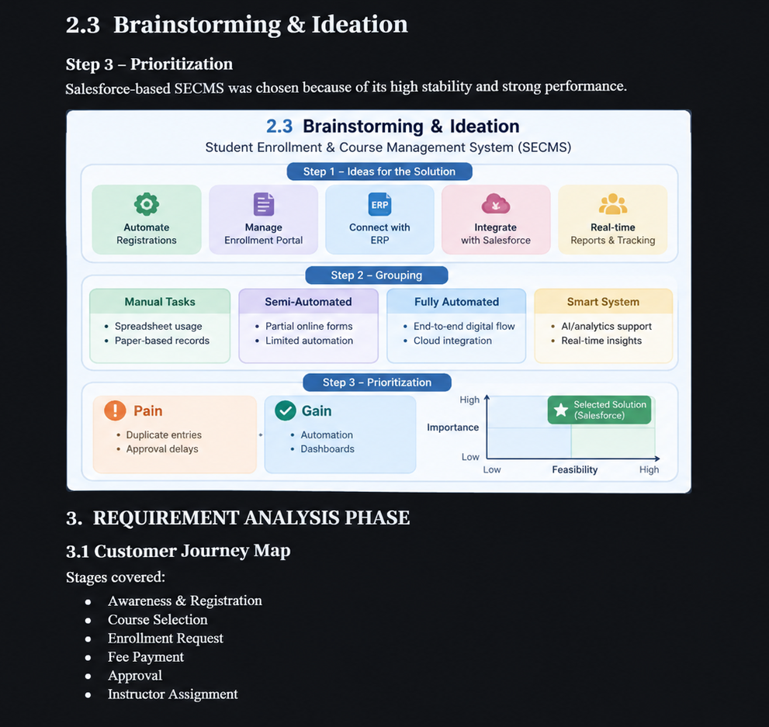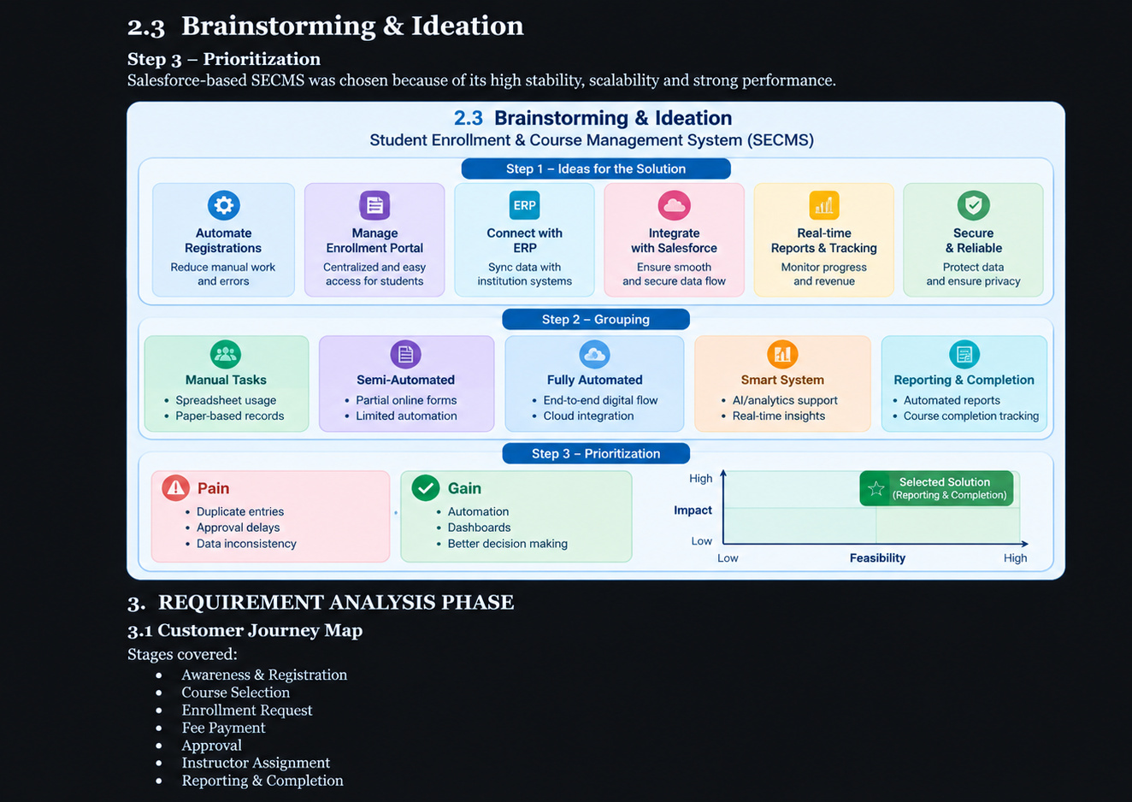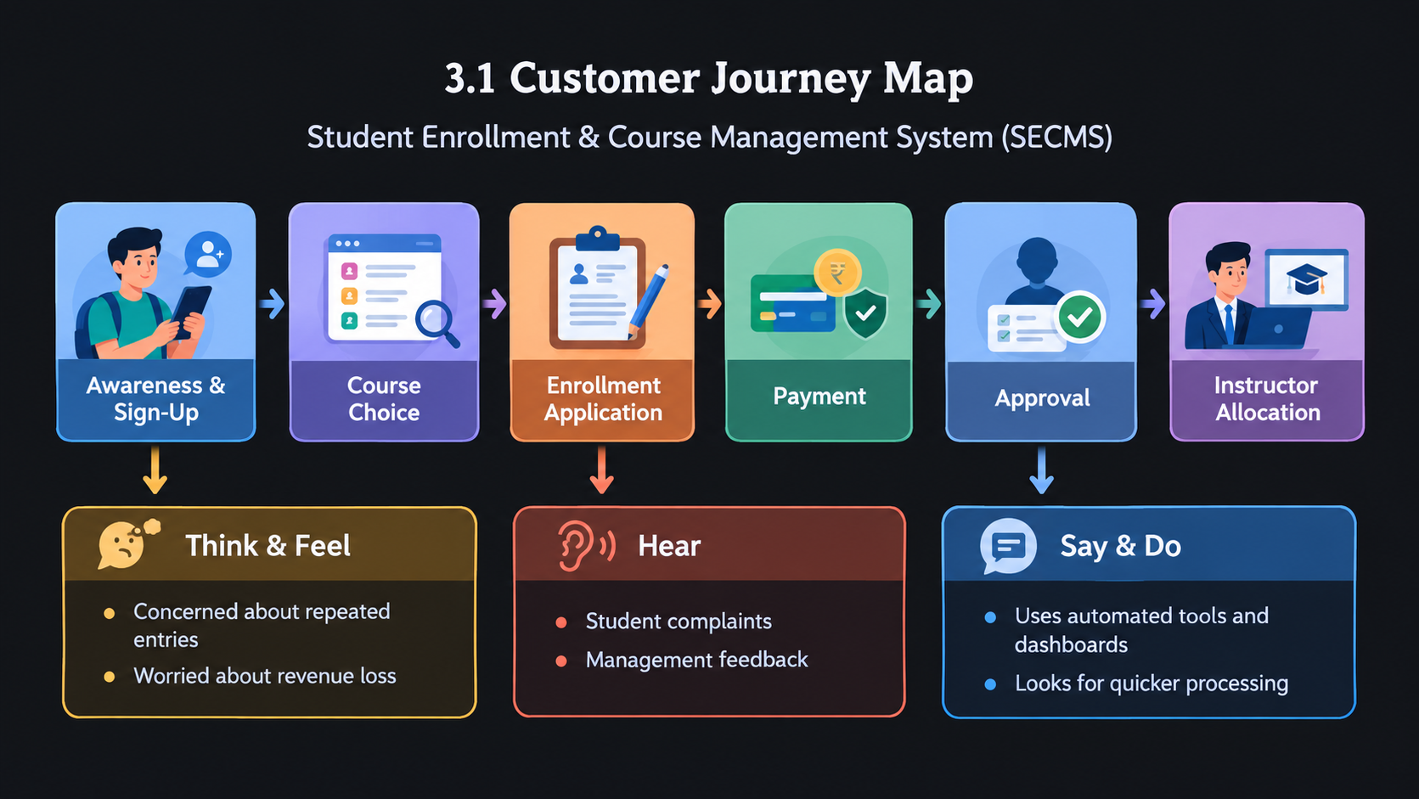
FR No | Epic | Description
FR-1 | Student Administration | Maintain and update student information
FR-2 | Course Administration | Add, modify, and manage available courses
FR-3 | Enrollment Management | Submit, approve, or decline enrollment requests
FR-4 | Instructor Allocation | Automatically allocate instructors to courses
FR-5 | Reporting | Generate reports and dashboard views

Non-Functional Requirements

NFR-1: Usability
The system should offer a clear, simple, and user-friendly interface that allows enrollment officers, administrators, instructors, and students to complete their tasks with minimal training. Navigation should be organized using easily identifiable tabs, dashboards, and forms to minimize user effort and reduce mistakes.
Examples:
- Simple student registration form
- Quick enrollment approval process
- Dashboards based on user roles

NFR-2: Security
The system shall maintain the privacy, safety, and integrity of student and institutional information through proper authentication, user permissions, and access restrictions. Confidential data such as personal details, enrollment information, and academic records must be accessible only to authorized users.
Examples:
- Only authorized administrators can modify course information.
- Instructors can access details of students assigned to them.
- Students are restricted from viewing other students’ information.

NFR-3: Reliability
The system shall provide stable and accurate performance during enrollment, approval, and reporting activities. Automated processes must function correctly and prevent duplicate or incorrect enrollment records.
Examples:
- The system should block repeated course registrations.
- Enrollment status should be updated correctly after approval.
- Reports should be generated accurately and consistently.

NFR-4: Performance
The system shall deliver quick response times for all major activities and maintain smooth operation even during busy admission periods.
Examples:
- Fast dashboard updates
- Quick student record searches
- Smooth processing of bulk data uploads

NFR-5: Scalability
The system shall be capable of supporting future growth in students, courses, departments, and users without reducing system performance. New features and modules should be easy to add when required.
Examples:
- Add new departments without changing the existing system
- Support increasing student admissions each year
- Allow integration with mobile applications or portals

NFR-6: Availability
The system shall remain accessible and dependable during institutional working hours with minimum service interruptions. It should provide continuous support for important academic activities.
Examples:
- Access to the system throughout the day
- Stable operation during admission periods
- Regular backup of student information

3.3 Data Flow Diagram
- User enters student and enrollment information.
- The system checks, validates, and saves the submitted data.
- Enrollment details are forwarded through the approval workflow.
- Processed information is used for instructor allocation.
- Reports and dashboards display the resulting information.
The system manages enrollment requests, verifies submitted details, handles approvals, allocates instructors, and provides reports for monitoring.

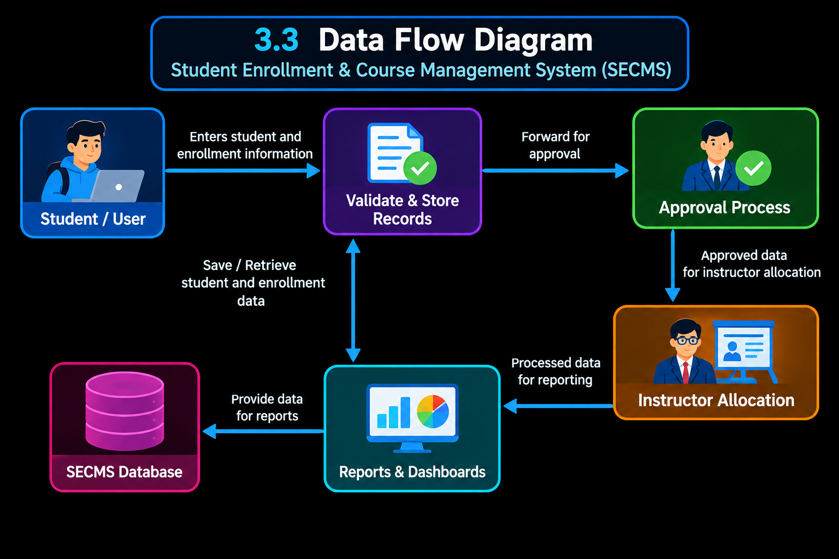3.4 Technology Stack
Layer | Technology
User Interface | Salesforce Lightning Experience
Business Logic | Salesforce Flow
Data Storage | Salesforce Objects
Process Automation | Validation Rules, Approval Workflows
Analytics&Reporting | Reports&Dashboards

4.1 Problem–Solution Fit
SECMS addresses the challenges in the existing enrollment process by connecting user needs with automated Salesforce-based solutions.

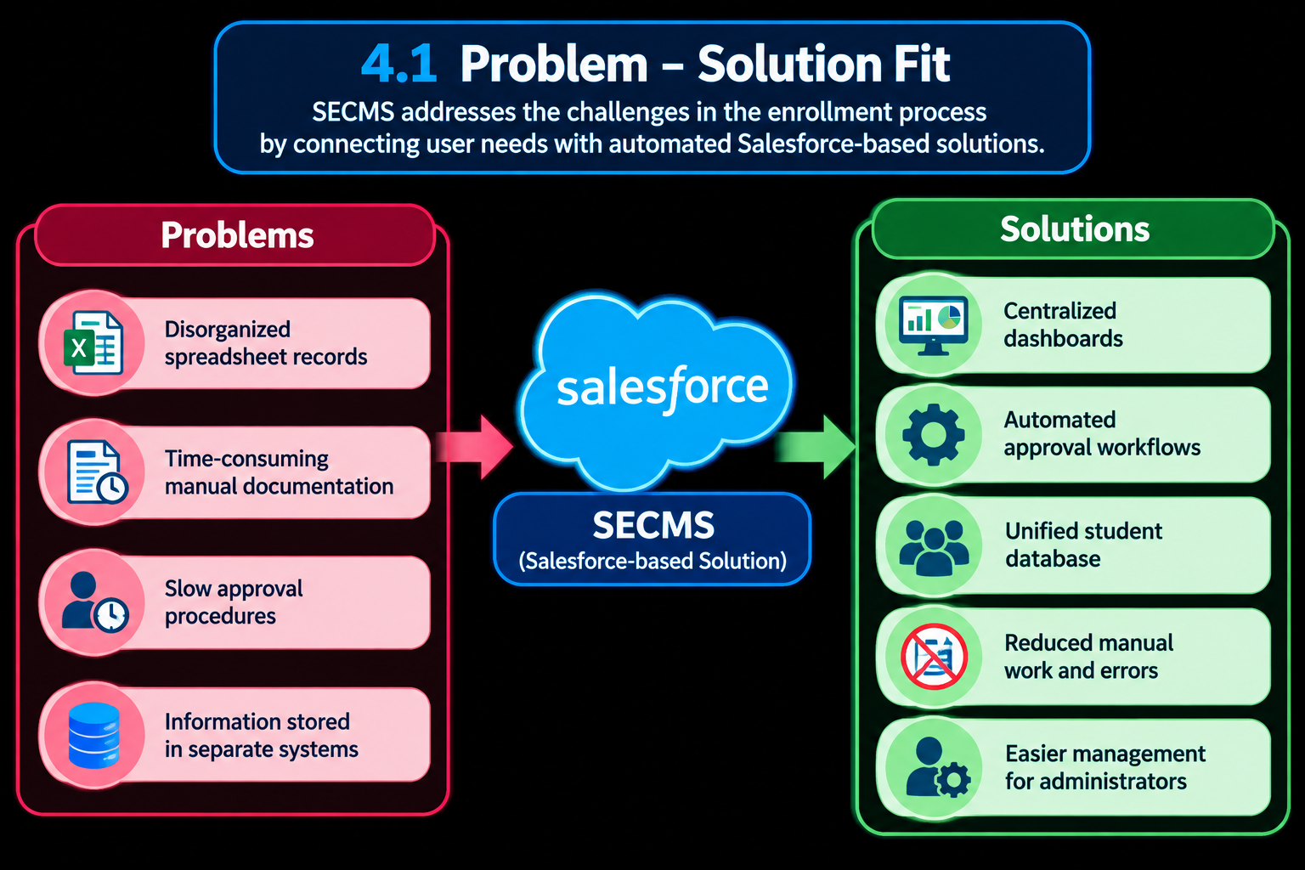4.2 Proposed Solution
Functional Requirements
Parameter | Description
Problem | Traditional enrollment management
Solution | Salesforce-powered SECMS
Novelty | Complete process automation
Social Impact | Enhanced student experience
Revenue Model | Deployment for educational institutions
Scalability | Support for multiple departments

4.3 Solution Architecture
The proposed architecture combines Salesforce objects, automated workflows, approval mechanisms, dashboards, and security controls to provide an integrated and efficient enrollment management system.

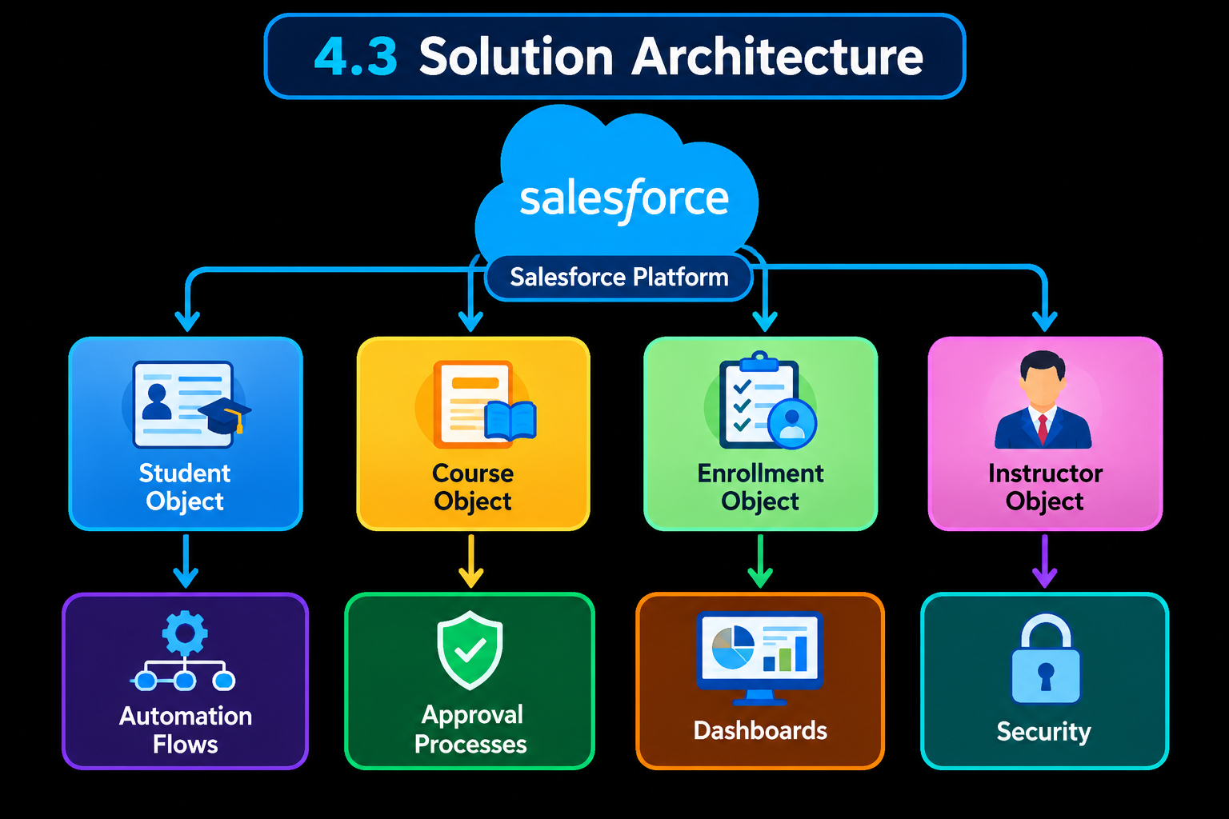5. PROJECT PLANNING&SCHEDULING

5.1 Project Planning
- Agile development approach
- Epics → User Stories → Story Points
- Development carried out in sprints
- Velocity is used for effort estimation
Product Backlog, Sprint Schedule, and Estimation (4 Marks)
Use the following template to prepare the product backlog and sprint schedule.
Sprint |  | Functional Requirement (Epic) | User Story Number |  | User Story / Task |  |  | Story Points |  | Priority |  | Team Members
Sprint-1 |  | Developer Setup | USN-1 |  | As a system administrator, I want to create a Salesforce developer account so that I can configure and deploy the Student Enrollment system. |  |  | 1 |  | High |  | Member1
Sprint-1 |  | Data Modeling | USN-2 |  | As an admin, I want to create custom objects for Student, Course, Enrollment, and Instructor so that academic data can be stored and managed efficiently. |  |  | 3 |  | High |  | Member2
Sprint-2 |  | Data Modeling | USN-3 |  | As a user, I want dedicated tables for each object so that I can easily navigate between students, courses, enrollments, and instructors. |  |  | 3 |  | High |  | Member3
Sprint-2 |  | Data Modeling | USN-4 |  | As an admin, I want to create relevant fields such as student details, course information, and enrollment status so that complete records can be captured accurately. |  |  | 5 |  | High |  | Member4
Sprint-2 |  | Data Modeling | USN-5 |  | As an enrollment officer, I want a centralized Lightning App so that I can access all academic operations from one interface. |  |  | 3 |  | High |  | Member4
Sprint-2 |  | Data Modeling | USN-6 |  | As an admin, I want to define relationships between students, courses, and enrollments so that the system can logically link and track academic activities. |  |  | 5 |  | Medium |  | Member1
Sprint-2 |  | Data Modeling | USN-7 |  | As a user, I want customized page layouts so that only relevant information is displayed, improving clarity and ease of data entry. |  |  | 5 |  | High |  | Member2
Sprint-3 |  | Automation | USN-8 |  | As a system, I want to validate input data such as mandatory fields and enrollment limits so that incorrect or incomplete records are prevented. |  |  | 3 |  | High |  | Member4
Sprint-3 |  | Automation | USN-9 |  | As a system, I want automated flows to handle enrollment processing and notifications so that manual effort is reduced and processes become faster. |  |  | 3 |  | High |  | Member4
Sprint-3 |  | Automation | USN-10 |  | As an administrator, I want an approval process for enrollment requests so that registrations are verified before confirmation. |  |  | 5 |  | High |  | Member1
Sprint-4 |  | Security | USN-11 |  | As an admin, I want to configure role-based security so that users can only access data relevant to their responsibilities. |  |  | 5 |  | High |  | Member2
Sprint-5 |  | Reports | USN-12 |  | As a manager, I want reports on student enrollments, course registrations, and instructor assignments so that I can monitor academic operations. |  |  | 4 |  | High |  | Member3
Sprint-6 |  | Dashboards | USN-13 |  | As a manager, I want visual dashboards showing enrollment |  |  | 4 |  | Medium |  | Member4
Sprint | Functional Requirement (Epic) |  |  | User Story Number |  | User Story / Task | Story Points |  | Priority |  | Team Members
 |  |  |  |  |  | statistics and trends so that I can quickly analyze system performance.

Project Tracker, Velocity&Burndown Chart: (4 Marks)
Sprint | Total Story Points | Duration | Sprint Start Date | Sprint End Date (Planned) | Story Points Completed (as on Planned End Date) | Sprint Release Date (Actual)
Sprint-1 | 20 | 6 Days | 24 Oct 2022 | 29 Oct 2022 | 20 | 29 Oct 2022
Sprint-2 | 20 | 6 Days | 31 Oct 2022 | 05 Nov 2022
Sprint-3 | 20 | 6 Days | 07 Nov 2022 | 12 Nov 2022
Sprint-4 | 20 | 6 Days | 14 Nov 2022 | 19 Nov 2022

6. Project Development Phase:
Project Flow:
Milestone 1: Salesforce Developer Account Creation
Milestone 2: Custom Object Creation (Student, Course, Enrollment, Instructor)
Milestone 3: Tabs Creation
Milestone 4: Lightning App Creation
Milestone 5: Fields Creation
Milestone 6: Create Relationships
Milestone 7: Page Layout Customization
Milestone 8: Validation Rules
Milestone 9: Flows (Automation)
Milestone 10: Approval Process
Milestone 11: Reports
Milestone 12: Dashboards
Milestone 13: Security Setup
Milestone 14: Conclusion

What you'll learn
- Real-time Salesforce project implementation
- Designing custom objects and relationships
- Creating page layouts & record types
- Writing validation rules
- Building automation with flows
- Creating approval workflows
- Developing reports & dashboards
- Setting up security with profiles, permission sets, and sharing
- End-to-end application testing

Milestone 1-Salesforce :
Introduction:
Are you new to Salesforce? Not sure exactly what it is, or how to use it?
Don’t know where you should start on your learning journey? If you’ve answered yes to any of these questions, then you’re in the right place. This module is for you.
Welcome to Salesforce! Salesforce is game-changing technology, with a host of productivity-boosting features, that will help you sell smarter and faster. As you work toward your badge for this module, we’ll take you through these features and answer the question, “What is Salesforce, anyway?”.
What Is Salesforce?

Salesforce is your customer success platform, designed to help you sell, service, market, analyze, and connect with your customers.
Salesforce has everything you need to run your business from anywhere. Using standard products and features, you can manage relationships with prospects and customers, collaborate and engage with employees and partners, and store your data securely in the cloud. So what does that really mean? Well, before Salesforce, your contacts, emails, follow-up tasks, and prospective deals might have been organized something like this:
https://youtu.be/r9EX3lGde5k

Activity 1: Creating Developer Account:
Creating a developer org in salesforce.
Go to https://developer.salesforce.com/signup
On the sign up form, enter the following details :
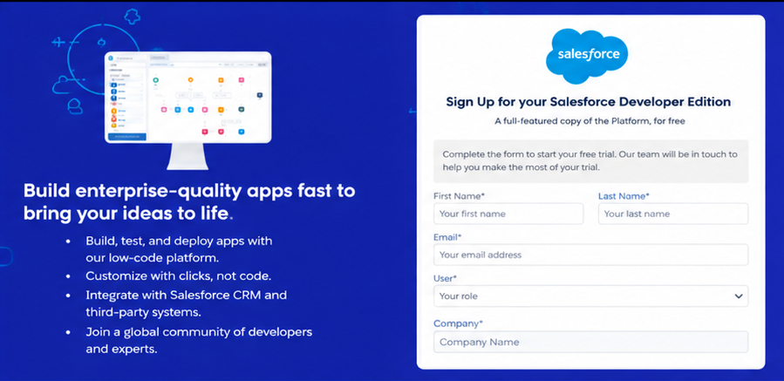First name&Last name
Email
Role : Developer
Company : College Name
County : India
Postal Code : pin code
Username : should be a combination of your name and company
This need not be an actual email id, you can give anything in the format : username@organization.com
Click on sign me up after filling these.

Activity 2: Account Activation:

1. Go to the inbox of the email that you used while signing up. Click on the verify account to activate your account. The email may take 5-10mins.
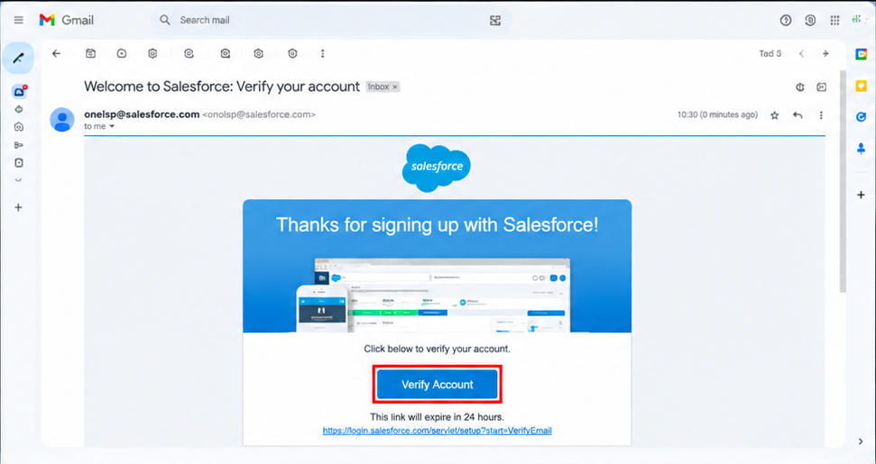2. Click on Verify Account
3. Give a password and answer a security question and click on change password.
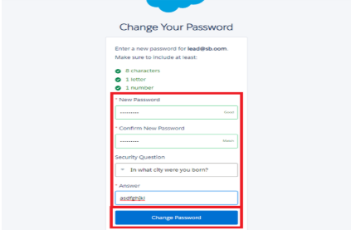
4. Then you will redirect to your salesforce setup page.

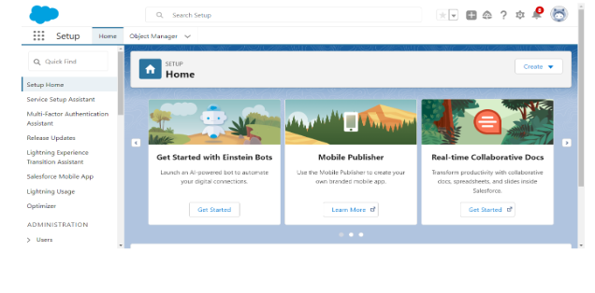Milestone 2 – Objects:

Activity 1: Creating Student Object:
The purpose of creating the Student custom object is to store and manage information about students such as their personal details, contact information, and enrollment status.

To create the Student object:

Go to the Setup page.

Click on Object Manager.

Click on Create → Custom Object.

Enter the details as below:
- Label: Student
- Plural Label: Students
- Object Name: Student
- Record Name: Student Name
- Data Type: Text
- Under Optional Features, select:
- Allow Reports
- Allow Activities (optional but recommended)
- Track Field History (optional, if you want)
- Under Search Status, select:
- Allow Search
- Click Save.
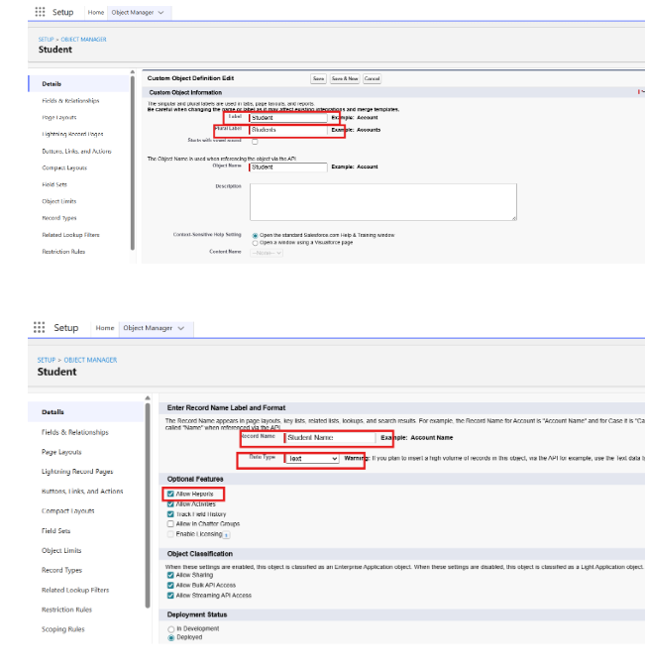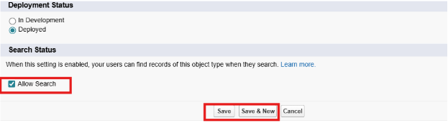In the same way Create Courses, Instructors, and Enrolments objects

Milestone 3 - Fields:

Table 1: Student Object Fields:

Field Label | Data Type
Student Name | Text (Standard)
Email | Email
Phone | Phone
Date of Birth | Date
Student Status | Picklist
Address | Text Area

Table 2: Course Object Fields:

Field Label | Data Type
Course Name | Text (Standard)
Category | Picklist
Duration | Number/Text
Course Fee | Currency
Description | Text Area

Table 3: Instructor Object Fields:

Field Label | Data Type
Instructor Name | Text (Standard)
Instructor Code | Text
Expertise | Picklist
Phone | Phone
Email | Email

Table 4: Enrollment Object Fields:

Field Label | Data Type
Student | Lookup (Student)
Course | Lookup (Course)
Instructor | Lookup (Instructor)
Enrollment Date | Date
Enrollment Status | Picklist
Fees Paid | Checkbox
Total Amount | Currency
Comments | Text Area

Milestone 4 – Create Relationships:

Activity 1: Create Lookup from Enrollment to Student:
- Go to Setup → click Object Manager.
- Type Enrollment in Quick Find → click Enrollment__c object.
- Click Fields&Relationships → click New.
- Select Lookup Relationship → click Next.
- For Related To, select Student__c → click Next.
- Enter Field Label: Student (API Name: Student__c).
- Click Next through Field-Level Security and Layout options (ensure it’s visible and added to layout).
- Click Save.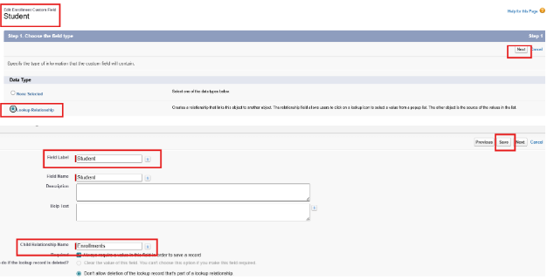

Activity 2: Create Lookup from Enrollment to Course
Purpose:
To link each Enrollment to a Course.

Steps:
- Go to Setup → Object Manager → Enrollment__c.
- Click Fields&Relationships → New.
- Select Lookup Relationship → Next.
- Related To: select Course__c → click Next.
- Field Label: Course (API Name: Course__c).
- Click Next (set visibility and layout) → Save.

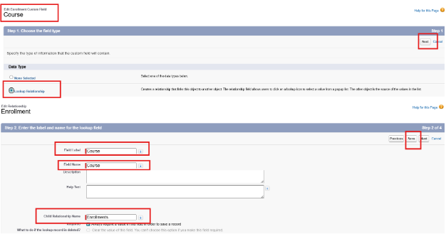Activity 3: Create Lookup from Enrollment to Instructor:
Purpose:
To store which Instructor is assigned to a particular Enrollment.

Steps:
- Go to Setup → Object Manager → Enrollment__c.
- Click Fields&Relationships → New.
- Choose Lookup Relationship → Next.
- Related To: select Instructor__c → Next.
- Field Label: Instructor (API Name: Instructor__c).
- Complete Field-Level Security and Page Layout options → Save

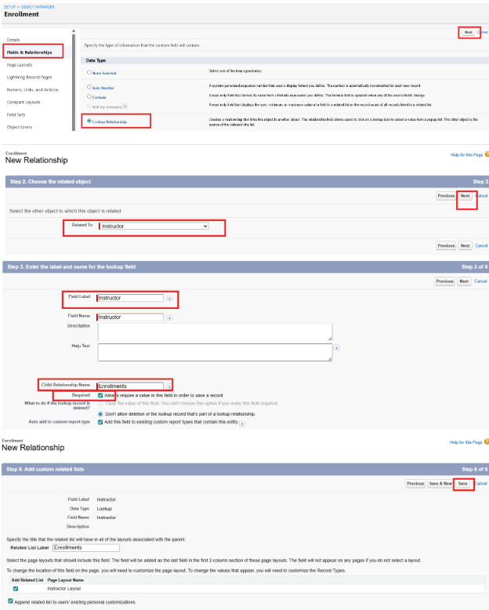Milestone 5 – Validation Rules:

Activity 1: Student Email Domain Validation
Purpose:
To ensure students use only allowed institutional email addresses.

Steps:

Go to Setup → Object Manager → Student__c.
Click Validation Rules → New.
Rule Name: Student_Email_Domain_Validation.
Error Condition Formula: (example for @student.edu)
- NOT(CONTAINS(Email__c, "@student.edu"))

Error Message: Email must be a valid student institutional email.
Error Location: Field → Email__c.
Click Save.

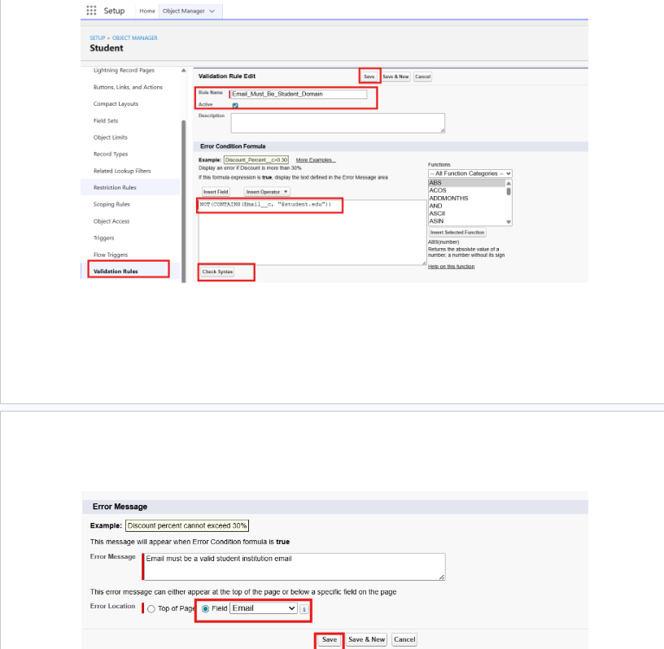Activity 2: Fees Must Be Paid Before Approval

Purpose:
Prevent Enrollment from being approved until fees are paid.

Steps:

- Go to Setup → Object Manager → Enrollment__c.
- Click Validation Rules → New.
- Rule Name: Fees_Must_Be_Paid_Before_Approval.
- Error Condition Formula:
AND(
ISPICKVAL(Enrollment_Status__c, "Approved"),
Fees_Paid__c = FALSE
)
5.Error Message: Fees must be paid before approving an enrollment.
6.Error Location: Top of Page (or field as needed).
Click Save.

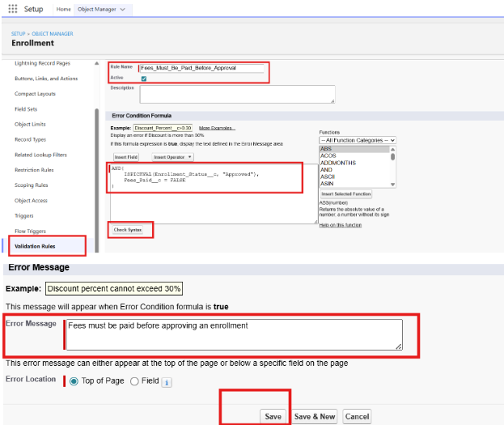Milestone 6 – Approval Process

Activity 1: Create Approval Process for Enrollment Requests

Purpose:
Route Enrollment requests to the Training Manager for approval or rejection.

Steps:

- Go to Setup → Approval Processes → select Enrollment__c.
- Click Create New Approval Process → Use Standard Setup.
- Process Name: Approval_Enrollment_Request.
- Entry Criteria: Enrollment_Status__c = "Requested".
- Save and configure steps.
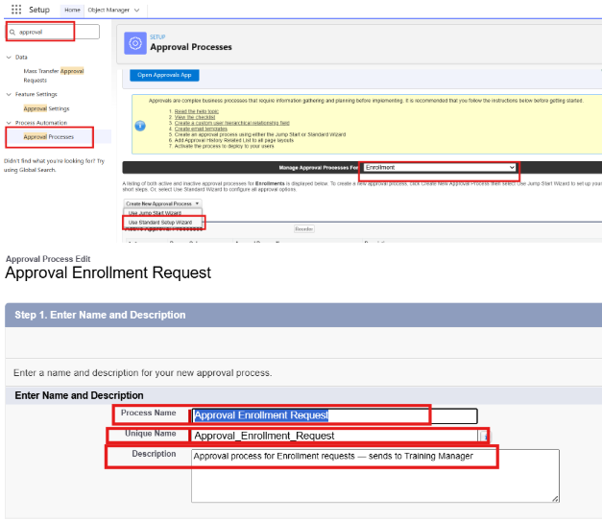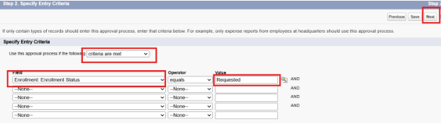6. Add Approval Step:
7. Approver: specific Training Manager user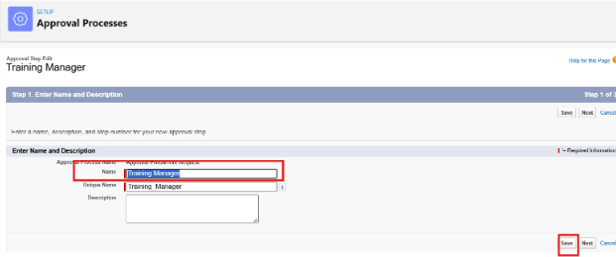 8.Under Final Approval Actions:
9.Add Field Update to set Enrollment_Status__c = "Approved".
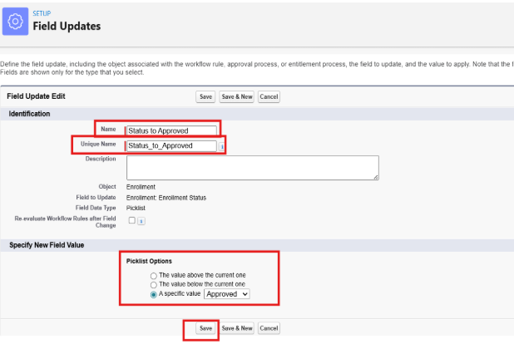
10. Under Final Rejection Actions:
11. Add Field Update to set Enrollment_Status__c=”Rejected”.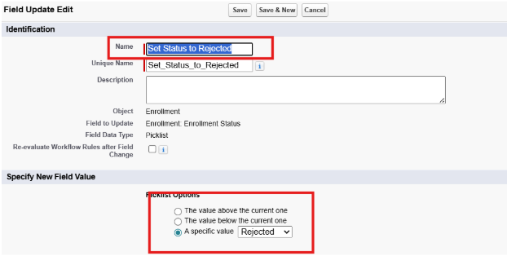 12. Add Email Alert to send rejection email to student.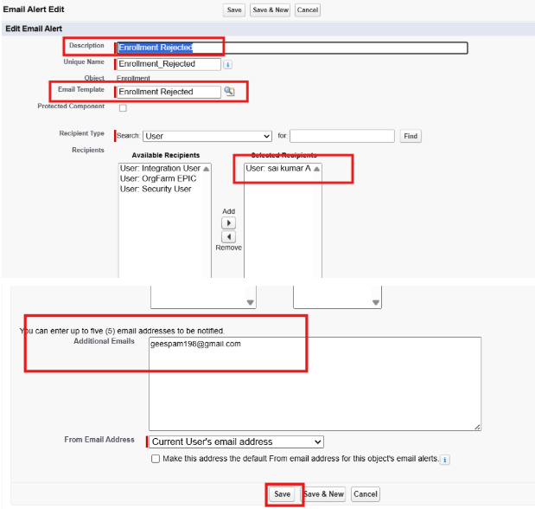 13. Activate the approval process.

Milestone 7- Tabs

Activity 1: Creating a Tab for the Student Object:
Go to Setup.
- In the Quick Find box, type Tabs.
- Under Custom Object Tabs, click New.
- Select Student from the object list.
- Choose a tab style (icon).
- Click Next, assign it to all profiles, and then click Save.

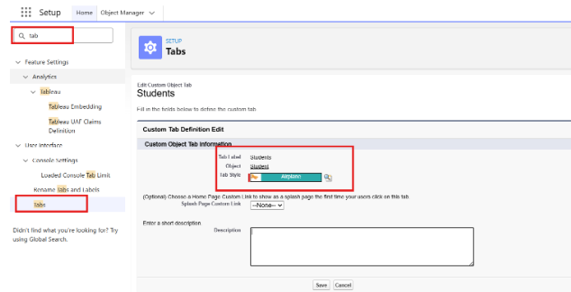Activity 2: Creating Remaining Tabs

Now create the Tabs for the remaining Objects, they are “Courses, Instructors, Enrollment”.
Follow the same steps as mentioned in Activity -1

Milestone 8 - The Lightning App

Activity 1: Creating the Lightning Application for the Project
Navigate to Setup.

Enter App Manager in the Quick Find search box.
Click New Lightning App.
Provide the app details:
App Name: Student Enrollment&Course Management
Developer Name auto-fills
Description: Optional, but can describe the purpose of the app
Click Next and choose the following settings:
App Branding (optional): Add logo or select color theme
Navigation Style: Choose Standard Navigation
Click Next and assign the app to specific profiles (e.g., Admin, Enrollment Officer, Instructor).
Click Next to select the items (tabs) to be included in the app. Add:
- Student
- Course
- Instructor
- Enrollment
- Reports
- Dashboards
- Home
- Tasks
- Click Next and review the app settings.
- Finally, click Save&Finish.

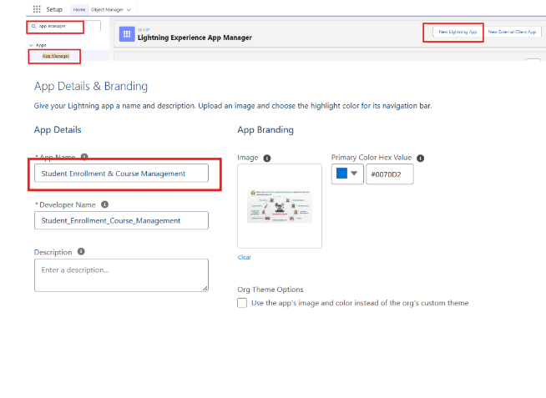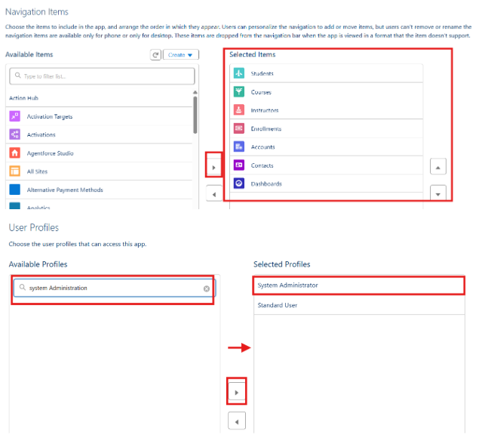Milestone 9 – Page Layouts and Record:

Activity 1: Create Record Types for Enrollment:

Purpose:
To separate New Enrollment vs Re-Enrollment processes.
Steps:
1.Go to Setup → Object Manager → Enrollment__c.
2.Click Record Types → New.
3.For the first record type:
- Existing Record Type: Master
- Record Type Label: New Enrollment
- Enable for required profiles (Admin, Enrollment Officer).
- Select the default Page Layout → Save&New.
4.For the second record type:
- Record Type Label: Re-Enrollment
- Enable for the same profiles.
- Select the default Page Layout → Save.

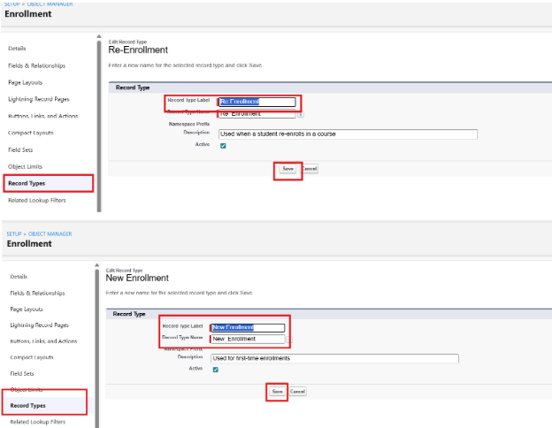Activity 2: Separate Page Layout Creators for Each Enrollment Record Type

Purpose:
To show different fields for New Enrollment vs Re-Enrollment.

Steps:

1.Enrollment__c object → click Page Layouts.
2.Click New to create a layout for New Enrollment:
- Clone from existing Enrollment Layout → name it New Enrollment Layout → Save.
- Keep fields relevant for first-time enrollment: Student, Course, Instructor, Enrollment Date, Status, Fees, etc.
- Remove unnecessary re-enrollment fields if any.
- Click Save.
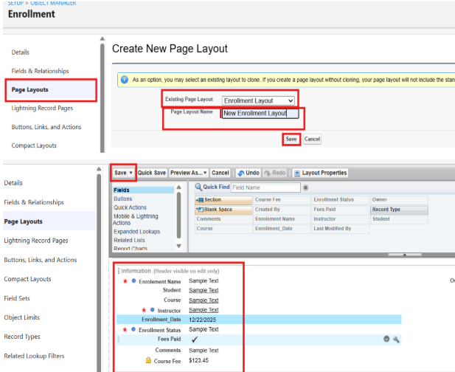3.Again, click New to create Re-Enrollment Layout:
- Clone existing layout → name it Re-Enrollment Layout → Save.
- Include fields like previous Enrollment reference (if any), Re-Enrollment Reason, Status, Fees, etc.
- Click Save.
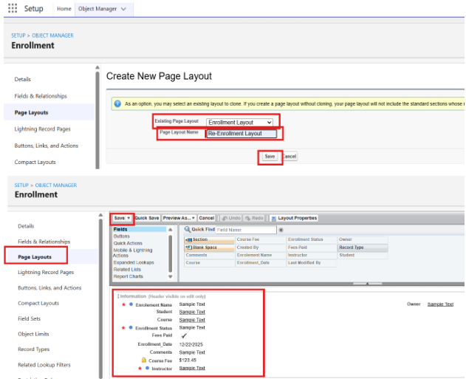4.Click Page Layout Assignment → Edit Assignment.
5.For each profile and record type:

- New Enrollment → use New Enrollment Layout.
6.Re-Enrollment → use Re-Enrollment Layout.
Click Save.

Activity 3: Enrollment R Addelated Lists to Parent Objects:

Purpose:
To see all Enrollments from Student, Course, and Instructor records.
a) Student → Enrollment Related List
Go to Setup → Object Manager → Student__c.
Click Page Layouts → open the main layout.
In the palette, select Related Lists.
Drag Enrollments related list onto the layout.
Customize columns if needed → Save.
b) Course → Enrollment Related List
Go to Object Manager → Course__c → Page Layouts.
Open layout → add Enrollments related list.
Save.
c) Instructor → Enrollment Related List
Go to Object Manager → Instructor__c → Page Layouts.
Open layout → add Enrollments related list.
Save.

Milestone 10 – Automation with Flow

Activity 1: Auto-Populate Enrollment Date (Record-Triggered Flow)

Purpose:
Set Enrollment_Date__c to today when Enrollment is created.

Steps:

- Go to Setup → Flows → New Flow.
- Select Record-Triggered Flow → Create.
- Object: Enrollment__c.
- Trigger: A record is created.
- Optimize for Actions and Related Records → Done.
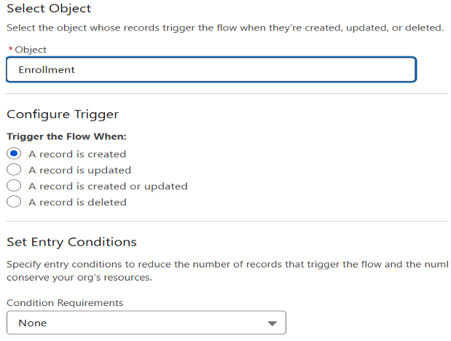
- Add Update Records element:
- Label: Set Enrollment Date.
- Use a record that triggered the flow.
- Field: Enrollment_Date__c → Value: $Flow.CurrentDate.
7.Save as SetEnrollmentDate → Activate.

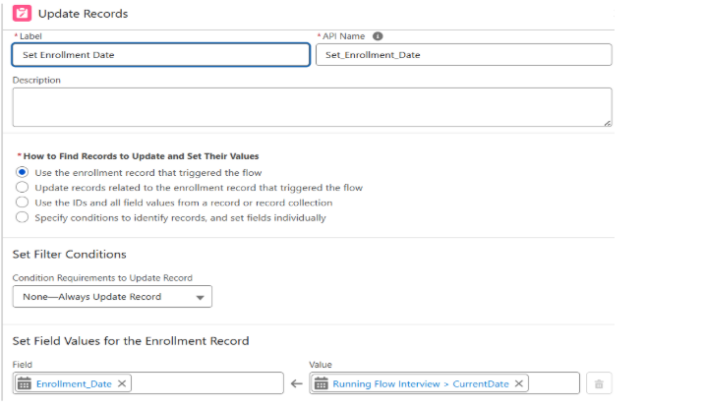Activity 2: Send Email When Enrollment Approved

Purpose:
When Enrollment_Status__c = Approved, send email, alert admin, and set Student to Active.
Steps (high level for document):

- Create Email Template and Email Alert for student notification.
- Go to Flows → New → Record-Triggered Flow.
- Object: Enrollment__c, Trigger on update.
- Condition: Enrollment_Status__c Equals "Approved".
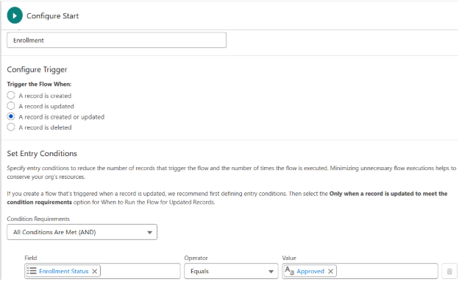
- Add Get Records to fetch related Student__c.
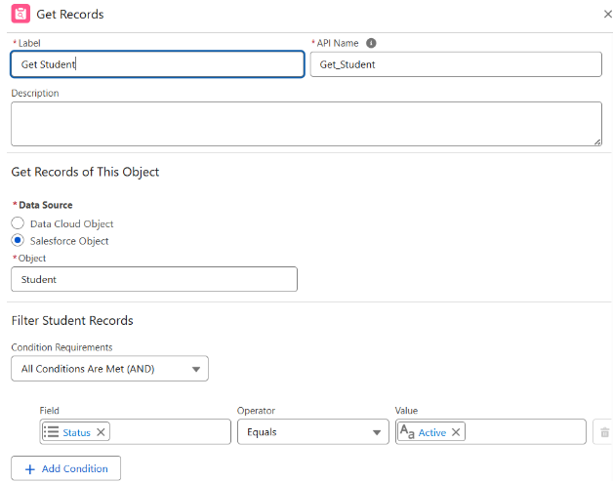
- Add Action (Email Alert) to send email to student.
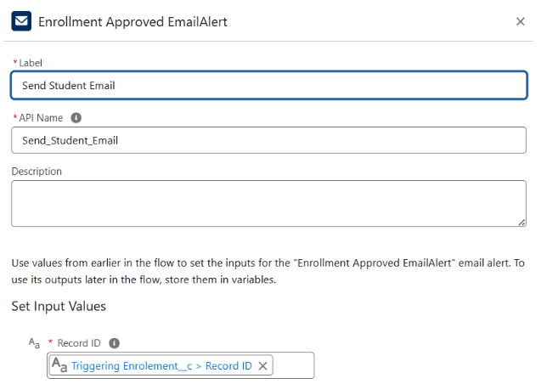
- Add Action to notify Admin if needed.
- Add Update Records to set Student__c.Status__c = "Active".
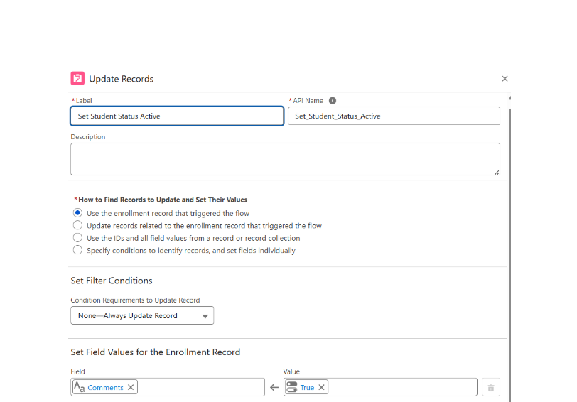9. Save as Enrollment Approved Action → Activate.

Activity 3: Auto-Assign Instructor Based on Course Category

Purpose:
Assign Instructor automatically based on Course category.

Rules:

Technical → Instructor A
Language → Instructor B
Non-Technical → Instructor C
Steps:

- Prepare Instructor__c records with codes (e.g., INSTR_A, INSTR_B, INSTR_C).
- Create Record-Triggered Flow on Enrollment__c (created/updated).
- Add Get Records to fetch related Course__c.
- Add Decision element on Course__r.Category__c:
- Technical / Language / Non-Technical outcomes.
- For each outcome:
- Get Instructor record (A/B/C) based on code or name.
- Update Records: set Instructor__c = Get_Instructor_X.Id.
- Save as AutoAssign_Instructor → Activate.

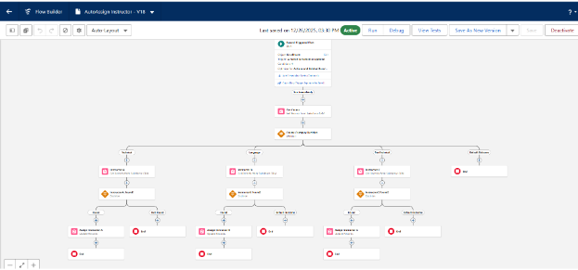Activity 4: Auto-Create Task for Follow-Up

Purpose:
When Enrollment is “Requested”, create a follow-up task for Admin.

Steps:

- Create Record-Triggered Flow on Enrollment__c.
- Trigger: Record created or updated; condition Enrollment_Status__c = "Requested".
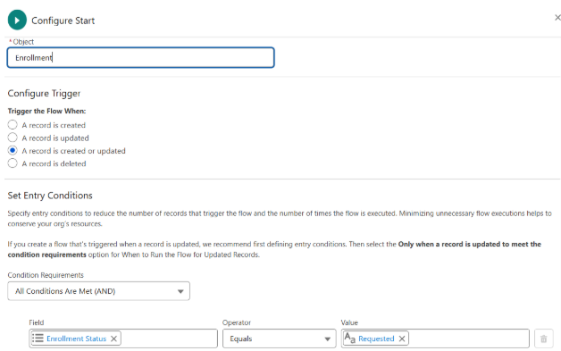

- Add Get Records to fetch Admin user (by Username / Profile).
- Add Formula (Date): TODAY() + 2 for due date.
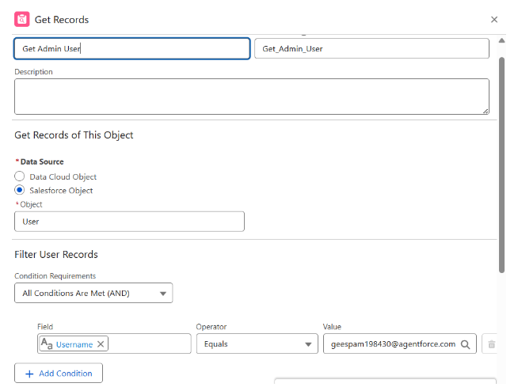
- Add Create Records for Task:
- Subject: Follow up on enrollment request.
- OwnerId: Admin user Id.
- WhatId: Enrollment Id.
- ActivityDate: formula Today + 2.
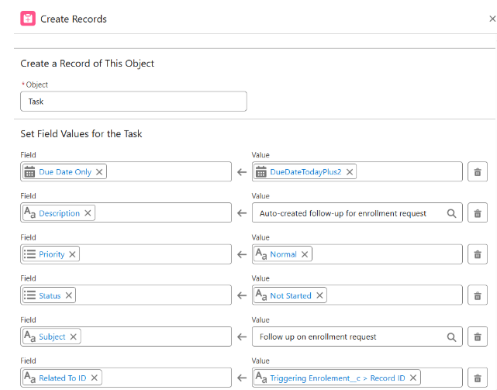
10.Save as Create_Followup_Task → Activate.

Milestone 11 – Reports:

Activity 1: Create “Students by Status” Report

1.Go to Reports → New Report.
2.Report Type: Students.
3.Group rows by Status__c.
4.Add columns as needed (Name, Email, Phone).
5.Save as Students by Status.
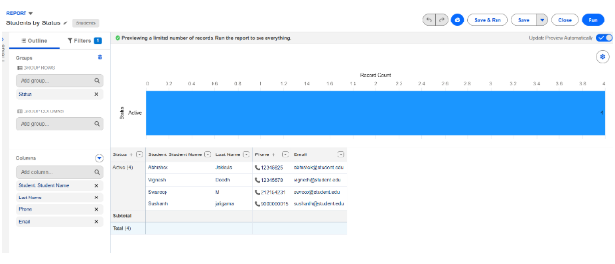

Activity 2: Create “Enrollments by Course” Report

1.New Report → Report Type: Enrollments.
2.Grouprows by Course__r.Name.
3.Show Record Count per course.
4.Save as Enrollments by Course
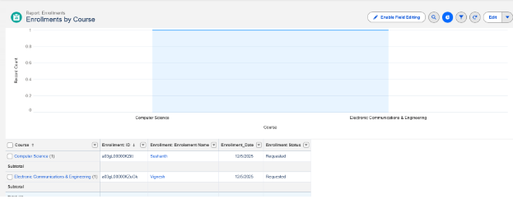

Activity 3: Create “Pending Enrollment Approvals” Report

- New Report → Enrollments report type.
- Filter: Enrollment_Status__c = "Requested".
- Add columns (Student, Course, Owner, Created Date).
- Save as Pending Enrollment Approvals.
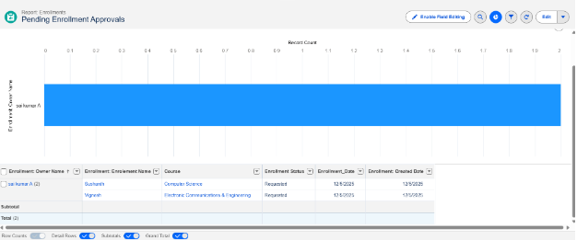

Activity 4: Create “Revenue Report (Fees Paid)” Report

1.New Report → Enrollments report type.
2.Filter: Fees_Paid__c = TRUE.
3.Group by Course__r.Name.
4.Summarize Course_Fee__c or similar fee field.
5.Save as Revenue Report – Fees Paid.
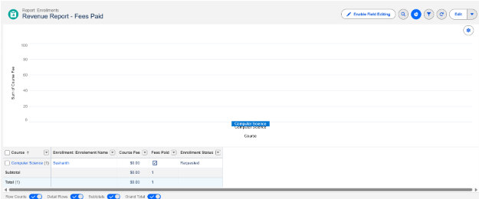

Milestone 12 – Dashboards:

Activity 1: Create “Student Managemet Dnashboard”

Steps:
- Go to Dashboards → New Dashboard.
- Name: Student Management Dashboard.
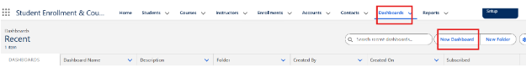
- Select folder → Create.
- Select the new Dashboard folder and Save.
Add components:
- Donut Chart → using Students by Status report.
- Bar Chart → using Enrollments by Course report.
- Gauge → using Revenue Report – Fees Paid (sum of revenue field).
- Table → using Pending Enrollment Approvals report.
- Arrange components on canvas.

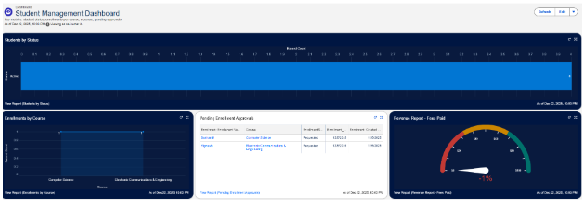
Click Save → Done.

Milestone 13 – Security Setup

Activity 1: Configure Profiles
):
- Go to Setup → Profiles → New (or CloneProfiles Required:
- Admin – Full access.
- Enrollment Officer – Create/Update Enrollments.
- Instructor – Read-only access to assigned Enrollments.
- Steps (example for Enrollment Officer fName: Enrollment Officer.
- In Object Settings:
  - Enrollment__c: Read, Create, Edit.
  - Student__c / Course__c: Read (and Edit if required).
- Save.
Repeat similarly for Instructor profile with Read-Only on Enrollments

Activity 2: Create Permission Sets

- Go to Setup → Permission Sets → New.
- Create Custom Object Access (additional access to project objects if needed).
- Create Dashboard Editor (Create/Customize Reports & Dashboards permissions).
- Assign to relevant users.

Activity 3: Configure Sharing&OWD

Steps:
- Go to Setup → Sharing Settings.
- Set Organization-Wide Defaults:
  - Students (Student__c): Public Read/Write.
  - Courses (Course__c): Public Read/Write.
  - Enrollments (Enrollment__c): Private.
- Save.
For Instructor access to assigned Enrollments, optionally:
- Add a User lookup on Enrollment (Instructor User).
- Use a simple Record-Triggered Flow to set OwnerId = Instructor User so they can see only their own records.

7. FUNCTIONAL&PERFORMANCE TESTING
During the testing stage, screenshots were taken from the Salesforce interface to confirm that the features developed for the Student Enrollment&Course Management System (SECMS) were working correctly. The testing covered student, course, instructor, and enrollment record creation; validation of required fields, eligibility conditions, and enrollment rules; and checking record type functionality for various course categories. Automated processes were also tested to verify enrollment approvals, seat availability, and automatic record updates. Apex triggers were validated to ensure that the required actions and data changes occurred correctly. In addition, reports and dashboards were reviewed through screenshots to confirm proper data presentation, enrollment monitoring, and system performance.
Submit the screenshots captured during the testing process.

8. ADVANTAGES&DISADVANTAGES

Advantages
- Centralized information management
- Efficient process automation
- Live monitoring and reporting

Disadvantages
- Reliance on the Salesforce platform
- Requires considerable setup and configuration initially

9. CONCLUSION
The Salesforce Student Enrollment&Course Management System provides an organized solution for managing the complete student academic process, including student registration, course creation, enrollment, instructor allocation, approvals, revenue management, and reporting. By using Salesforce features such as validation rules, automated flows, approval processes, and dashboards, the system helps maintain accurate information and improves the efficiency of academic operations. This project demonstrates how Salesforce can replace manual processes with a structured, scalable, and easy-to-use digital system.

10. FUTURE SCOPE
- Integration with online payment services
- Student-accessible self-service portal
- Advanced data analysis and reporting
- Mobile application and device support

11. APPENDIX
- Source Code: Salesforce setup and configuration details
- Dataset: Records and data stored in Salesforce objects
- GitHub / Demo: Salesforce Developer Org project demonstration

Thank You

